TITLE OF YOUR PAPER. UPPERCASE.
First AUTHOR, Second AUTHOR
Affiliation
Abstract: Abstract length: 100-150 words. Present a brief account of the most relevant aspects of your paper. Abstract length: 100-150 words. Present a brief account of the most relevant aspects of your paper. Abstract length: 100-150 words. Present a brief account of the most relevant aspects of your paper. Abstract length: 100-150 words. Present a brief account of the most relevant aspects of your paper. Abstract length: 100-150 words. Present a brief account of the most relevant aspects of your paper.
Keywords: 5 keywords.

- Introduction
Please do not change the formatting and style layouts which have been set up in this template. (Calibri, 12p.)
Papers should be prepared in a single column. Do not insert page numbers or footnotes (please use endnotes instead). Use italics for emphasis, keywords, etc. Use the corresponding diacritic signs for the language in which you write the paper.
- Body of your paper
Paper length: 5000-7000 words (title, abstract, keywords and references included). If your paper is written in German or any other language, provide an English translation of the paper’s title, abstract and keywords and introduce them at the end of your paper (this part should not count in the overall paper length.

Introduce a brief biographical paragraph in English (80-150 words, Calibri, 10 p., single spaced) after References. Suggested content: affiliation, position, research interests, courses you give, published books, etc.

  - Tables
All tables should be centered and numbered with Arabic numerals. Place the heading under the table, centered. All tables should be embedded in the text. Use Calibri, 10p. single spaced. Use 6p. spacing before and after the table.
Test table | Test table | Test table | Test table
Test table | Test table | Test table | Test table
Table 1. Name of the table

  - Examples
All examples should be numbered. Use Calibri, 9p. single spaced. Use 6p. spacing before and after examples:
- First example.
- Second example.
- Third example.
All examples should be numbered. Use Calibri, 10p. single spaced. Use 6p. spacing before and after examples.

  - Figures
All photographs, schemas, graphs and diagrams are to be referred to as figures. All figures should be centered and numbered with Arabic numerals. All figures should be good quality .jpeg files, embedded in the text. Place the heading under the figure, centered. Figures should be placed at the top or bottom of the page wherever possible, and as close as possible to their first point of reference in the paper. Use 6p. spacing before and after each figure.

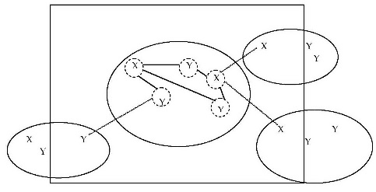
Figure 1. Name of the figure

  - References
All references given in the paper should be included in a list of references, at the end of the paper. The list should be given in alphabetical order as below. Use Calibri, 10p. single spaced, justified.
References
McElroy, W. D. 1999. A Manual of Style, 12th ed. Chicago: The University of Chicago Press.
Owyoung, A. 1979. "High Resolution Coherent Raman Spectroscopy of Gases". In H. Walther and K. W. Rothe (eds.) Laser Spectroscopy IV. New York: Springer- Verlag, pp. 175-182.
Thole, K., 1997. "Exploring the Possibility of Primitive Life on Mars" in Undergraduate Engineering Review, available at http://tc.engr.wisc.edu/tcweb/uer/uer97/thole.html [accessed May 2009].

BIOGRAPHICAL PARAGRAPH

John BROWN, PhD, is … Each author should introduce here a brief biographical paragraph in English (80-150 words, Calibri, 10p., single spaced). Suggested content: affiliation, position, research interests, courses you give, published books, etc. E-mail: john.smith@domain.com

TITLE, ABSTRACT, KEYWORDS

If your paper is written in German or any other language, provide an English translation of the paper’s title, abstract and keywords and introduce them here. (This part should not count in the overall paper length.)

